**REG NO:**

**SRM Institute of Science and Technology**



**College of Engineering and Technology**

**School of Computing**

SRM Nagar, Kattankulathur – 603203, Chengalpattu District, Tamilnadu

**Academic Year: 2023-24 (ODD) MCQ**

**Test: CLA-T3** **Date: 09-11-2023**

**Course Code & Title: 18CSE308T -AWS Solution Architect** **Duration:** **20 Minutes**

**Year & Sem: III Year / V Sem** **Max. Marks:** **10**

**Course Articulation Matrix: *(to be placed)***

|  |  |  |  |  |  |  |  |  |  |  |  |  |  |
| --- | --- | --- | --- | --- | --- | --- | --- | --- | --- | --- | --- | --- | --- |
| **S.No.** | **Course Outcome** | **PO1** | **PO2** | **PO3** | **PO4** | **PO5** | **PO6** | **PO7** | **PO8** | **PO9** | **PO10** | **PO11** | **PO12** |
| 1 | **CO1** | 2 |  |  |  | 3 |  |  |  |  |  |  |  |
| 2 | **CO2** | 3 |  |  |  |  |  |  |  |  |  |  |  |
| 3 | **CO3** | 2 |  |  | 3 |  |  |  |  |  |  |  |  |
| 4 | **CO4** |  | 3 |  |  |  |  |  |  |  |  |  |  |
| 5 | **CO5** |  |  |  | 3 |  |  |  |  |  |  |  |  |

|  |  |  |  |  |  |  |
| --- | --- | --- | --- | --- | --- | --- |
| **Part - A**  **(10 x 1 = 10 Marks)**  **Instructions: Answer all** | | | | | | |
| **Q. No** | **Question** | **Marks** | **BL** | **CO** | **PO** | **PI Code** |
| **1** | What is the primary advantage of using container orchestration platforms like Kubernetes in a containerized environment?  a) They simplify the process of creating Docker images.  b) They provide a graphical user interface for managing containers.  **c) They automate the deployment, scaling, and management of containers.**  d) They provide security patches for containerized applications. | **1** | **L2** | **4** | **1** | **1.6.1** |
| **2** | You have a legacy monolithic application that you want to migrate to a microservices architecture on AWS. Which AWS service would you use for API management and gateway functionality?  a) Amazon RDS  **b) Amazon API Gateway**  c) AWS Lambda  d) Amazon S3 | **1** | **L2** | **4** | **2** | **2.6.3** |
| **3** | You have a large dataset in Amazon S3 that you want to analyze with Amazon Redshift. What service or feature would you use to load data from S3 into Redshift?  a) Amazon QuickSight  b) Amazon Athena  **c) Amazon Glue**  d) Amazon Redshift Spectrum | **1** | **L2** | **4** | **2** | **2.6.3** |
| **4** | You want to use AWS Glue to transform data stored in Amazon S3 and load it into Amazon Redshift. Which AWS Glue component would you use for this task?  a) AWS Glue Crawler  **b) AWS Glue Job**  c) AWS Glue Data Catalog  d) AWS Glue ETL | **1** | **L2** | **4** | **2** | **2.6.3** |
| **5** | What is AWS CloudWatch?  a) A cloud-based file storage service  b) A managed container orchestration service  **c) A monitoring and logging service for AWS resources**  d) A machine learning service for image recognition | **1** | **L2** | **4** | **1** | **1.6.1** |
| **6** | What is the primary purpose of AWS CloudTrail?  a) To store backup copies of your data  b) To monitor the health of your EC2 instances  **c) To capture and record all API actions performed in your AWS account**  d) To manage container deployments | **1** | **L2** | **5** | **1** | **1.6.1** |
| **7** | How does AWS Config store historical configuration changes?  **a) In Amazon S3 buckets**  b) In Amazon RDS databases  c) In Amazon DynamoDB tables  d) AWS Config does not store historical changes. | **1** | **L2** | **5** | **5** | **5.4.1** |
| **8** | Which AWS resource is commonly protected by AWS Shield?  a) Amazon S3 buckets  b) AWS Lambda functions  c) AWS Identity and Access Management (IAM) roles  **d) Elastic Load Balancers (ELBs)** | **1** | **L2** | **5** | **1** | **1.6.1** |
| **9** | Which AWS service is often integrated with AWS WAF to provide protection against Distributed Denial of Service (DDoS) attacks?  a) Amazon S3  b) Amazon RDS  **c) Amazon CloudFront**  d) AWS Lambda | **1** | **L2** | **5** | **1** | **1.6.1** |
| **10** | What is the purpose of a Network Access Control List (NACL) in an Amazon VPC?  a) To control access to Amazon S3 buckets.  b) To define security groups for EC2 instances.  **c) To filter traffic at the subnet level.**  d) To manage IAM roles. | **1** | **L2** | **5** | **1** | **1.6.1** |

**\*Program Indicators are available separately for Computer Science and Engineering in AICTE examination reforms policy.**

**Course Outcome (CO) and Bloom’s level (BL) Coverage in Questions**

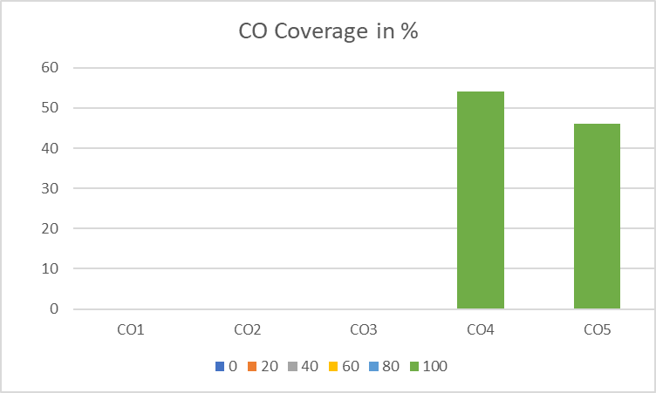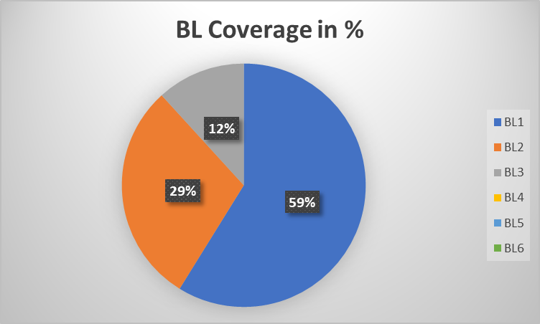

**Approved by the Audit Professor/Course Coordinator**